**CBS810 Lab 2: Simulation of Compartment Models**

Shi Chen schen31@ncsu.edu

**Learning objectives:**

Learn the basics of R functions

Simulate SIR type models with R

**Function**

y=f(x)

**Input** [x] 🡪 **Mapping/Transformation** [f(x)] 🡪 **Output** [y]

**An Example**

# Compute Harmonic Means

harmonic<-function(x) { # function name and input

y=1/mean(1/x) # function body

y # output value

} # end of function

# Try to Run the Harmonic Function

harmonic(c(1:4))

mean(c(1:4))

**In-Class Activity: Write a function to estimate the human-age of the dog**

The age of a dog is approximately 6 times of that of a man (e.g. a 5-yr old dog is approximately like a 30 yr-old man:)

**The Compartment Model in R: Epidemic SIR Model**

install.packages(deSolve) # first, install the R package necessary for simulation of ODE; only once

library(deSolve) # load the package every time we need to use it – R will not load it by default!

# Here is our customized function for Epidemic SIR model

sir.model <- function (t, x, params) { # The function head

S <- x[1] # Susceptible

I <- x[2] # Infected

R<-x[3] # Recovered

beta <- params[1] # transmission coefficient

gamma<-params[2] # recovery rate

dS <- -beta*S*I # translate from the equation for dS

dI <- beta*S*I - gamma*I

dR<- gamma*I

list(c(dS,dI,dR)) # list the out puts

}

#########################

# Specify parameters, initial values, and time step

parms <- c(beta=1e-3, gamma=1e-1) # specify the parameters

inits <- c(S=499,I=1,R=0) # specify the initial values for the variables

dt <- seq(0,100,0.1) # specify time step in simulation

# Run the simulation

sim.2 <- as.data.frame(lsoda(inits, dt, sir.model, parms=parms)) # run the model

plot.ts(sim.2$I,lwd=2,ylim=c(0,500),ylab="Number", main="SIR model") # plot part

lines(c(1:1001),sim.2$S,col="blue",lty=2,lwd=2)

lines(c(1:1001),sim.2$R,col="green",lty=3,lwd=2)

leg.txt<-c("Infected","Susceptible","Recovered")

legend("topright",leg.txt,lty=c(1,2,3),col=c("black","blue","green"))

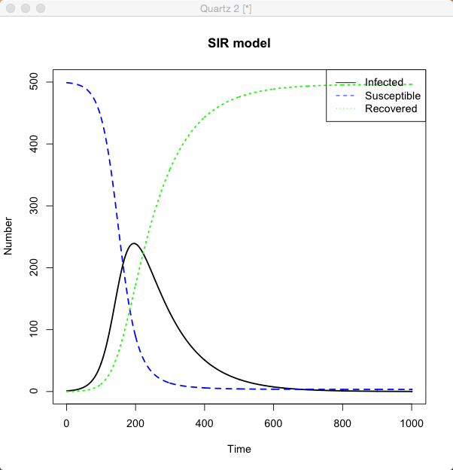

1. Try to derive the steady-state (equilibrium) for the SIR model. Compare your result with the simulation figure, do they align well?

2. Change the parameters in the model and see how the result changes accordingly!

3. Modify the SIR code to accommodate the epidemic SEIR model

(HINT: use your homework’s solution as a guide for the codes!)

You can try endemic SEIR model if you want some challenge!